Data Communications -1
Project-1
Name: Yakaiah.B
UML ID: UMS 01244568
Email-yakaiah_bommishetti@student.uml.edu

OUTPUT:
GET:
C:\>cd Program Files
C:\Program Files>cd Datacom
C:\Program Files\Datacom>javac *.java
1# C:\Program Files\Datacom>java HttpClient www.google.com 80 GET index.html
HTTP/1.1 302 Found
Location: http://www.google.com/
Cache-Control: private
Content-Type: text/html; charset=UTF-8
X-Content-Type-Options: nosniff
Date: Tue, 18 Oct 2011 17:50:17 GMT
Server: sffe
Content-Length: 219
X-XSS-Protection: 1; mode=block

<HTML><HEAD><meta http-equiv="content-type" content="text/html;charset=utf-8">
<TITLE>302 Moved</TITLE></HEAD><BODY>
<H1>302 Moved</H1>
The document has moved
<A HREF="http://www.google.com/">here</A>.
</BODY></HTML>

2#C:\Program Files\Datacom>java HttpClient localhost 80 GET index.html
HTTP/1.1 400 Bad Request
Date: Tue, 18 Oct 2011 17:50:54 GMT
Server: Apache/2.2.21 (Win32)
Content-Length: 226
Connection: close
Content-Type: text/html; charset=iso-8859-1

<!DOCTYPE HTML PUBLIC "-//IETF//DTD HTML 2.0//EN">
<html><head>
<title>400 Bad Request</title>
</head><body>
<h1>Bad Request</h1>
<p>Your browser sent a request that this server could not understand.<br />
</p>
</body></html>

PUT:
Running Server:
C:\Program Files\Datacom>java HttpServer 5678
HttpServer running on port 5678.
<Access Log>: PUT test.html HTTP/1.1
<Access Log>: GET test.html HTTP/1.1
<Access Log>: GET test.html HTTP/1.1

Client Side outputs:
C:\>cd Program Files
1#C:\Program Files>java HttpClient localhost 5678 PUT test.html
HTTP/1.0 201 Created
Server: Httpd
Date: Tue Oct 18 23:23:06 IST 2011
Content-Type: text/html
Content-Length: 11
*File is sent to server by using PUT .
2#C:\Program Files>java HttpClient localhost 5678 GET test.html
HTTP/1.0 200 OK
Server: Httpd
Date: Tue Oct 18 23:23:42 IST 2011
Content-Type: text/html
Content-Length: 110
Localhost Screenshot:

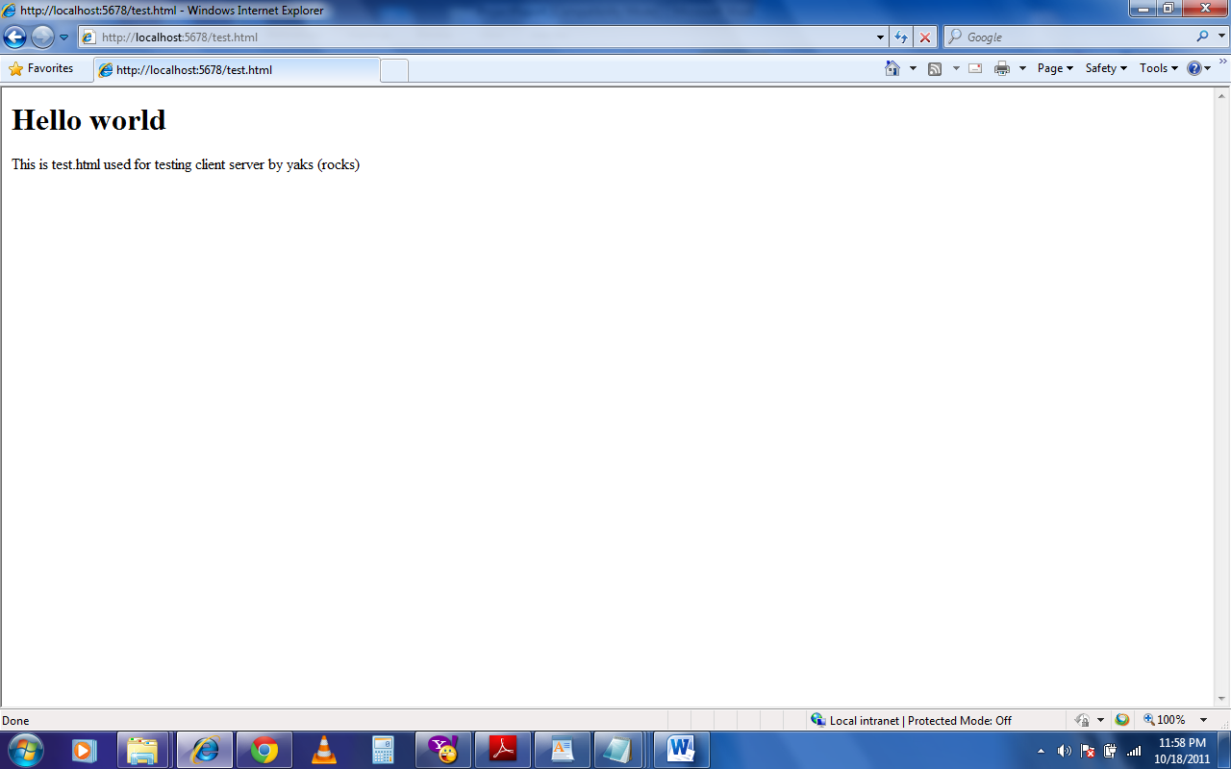

Source code
HttpClient.java:

import java.io.*;//Standard header files for input output

import java.net.*;//Header files for the support of data communication

// HttpClient is a simple web client. It supports GET and PUT.

public class HttpClient {

//Creation of private variables needed for the sake of connecting to server

private String host;// takes the ip address or the host name
private int port;//default is 80 ..

private String action;

private String fileName;

private InputStream from_server;

private OutputStream to_server;

private Socket socket = null;

//Once the client object is created the following constructor takes care of actions
//which are to be performed

HttpClient(String host, int port, String action, String fileName){

this.host = host;

this.port = port;

this.action = action;

this.fileName = fileName;

doAction();

}

private void doAction(){

try {

// Open a network socket connection to the specified host and port

socket = new Socket(host, port);

// Get input and output streams for the socket

from_server = socket.getInputStream();

to_server = socket.getOutputStream();

//Checking upon which action to apply (get or put)

if(action.equalsIgnoreCase("get"))

doGetMethod();

else if (action.equalsIgnoreCase("put"))

doPutMethod();

else

doNotImplemented();//if get or put are not specified

socket.close();

} catch (Exception e) {

e.printStackTrace();

}

}

// Sends the GET Request to the Server and prints the response.

// Get method prints the output in the command prompt !

private void doGetMethod() throws Exception{

String theLine;

// Send the HTTP GET command to the Web server.

String req = action + " " + fileName + " "+ "HTTP/1.0" + "\n\n";

to_server.write(req.getBytes());

BufferedReader br=new BufferedReader(new InputStreamReader(from_server));

while ((theLine = br.readLine()) != null) {

System.out.println(theLine);
}
}

// Sends the PUT Request to the Server and prints the response.

//format myclient host port_number PUT filename

private void doPutMethod() throws Exception {

FileInputStream file = null;

byte[] data = new byte[1024];

int inCount;

String theLine;

try {

// Send the HTTP PUT command to the Web server.

String req = action + " " + fileName + " "+ "HTTP/1.0" + "\n\n";

to_server.write(req.getBytes());

// Open the file.

file = new FileInputStream(fileName);

// Read and send file data.

while (true) {

inCount = file.read(data);

if (inCount == -1) {

break;

}

to_server.write(data, 0, inCount);

}

// End of stream.

socket.shutdownOutput();
BufferedReader br=new BufferedReader(

new InputStreamReader(from_server));

while ((theLine = br.readLine()) != null) {

System.out.println(theLine);

}

}catch(Exception e){

e.printStackTrace();

} finally {

from_server.close();

to_server.close();

file.close();

}
}
// Other than GET/PUT Requests.
private void doNotImplemented(){

System.out.println("Only GET & PUT are implemented.");

}

// Entry point to the program.

public static void main(String[] args) {

// Check the arguments

if (args.length != 4) {

System.out.println("HttpClient server port_number GET/PUT filename");

System.exit(0);

}

//Taking inputs from command line!

String host = args[0];

int port = Integer.parseInt(args[1]);

String action = args[2];

String fileName = args[3];
HttpClient client = new HttpClient(host, port, action, fileName);

}

HttpServer:

import java.io.*;
import java.net.*;
/**
* HttpServer is a simple web server. It supports only the GET and PUT methods.
*/
public class HttpServer {
private int serverPort;
public static void main(String[] args) {
int port = 80;
// Get command-lines arguments. If command-line arg "port" cannot be
// converted to an integer, print a usage message and exit.
if (args.length >= 1) {
try {
port = Integer.parseInt(args[0]);
} catch(NumberFormatException ex) {
System.out.println("Usage: HttpServer [port]");
System.exit(0);
}
}
(new HttpServer(port)).begin();
}
/**
* Constructs a new HttpServer that listens on the specified port.
*/
public HttpServer(int port) {
super();
this.serverPort = port;
}
/**
* Starts the server.
*/
public void begin() {
ServerSocket httpSocket;
Socket clientSocket;
ServerThread requestThread;
try {
// Creates a server socket.
httpSocket = new ServerSocket(serverPort);
System.out.println("HttpServer running on port " + serverPort + ".");

try {
while (true) {
// Accept any client connection.
clientSocket = httpSocket.accept();
// Start a thread to service the client request.
requestThread = new ServerThread(clientSocket);
requestThread.start();
}
} finally {
httpSocket.close();
}
} catch(Exception ex) {
System.out.println(ex.toString());
}
System.exit(0);
}
}

ServerThread

import java.io.*;
import java.net.*;
import java.util.*;
/**
* This class services client requests.
*/
public class ServerThread extends Thread {
private Socket clientSocket;
private OutputStream out;
private InputStream in;
private BufferedReader socketReader;
/**
* Constructs a request thread for the given client socket.
*/
public ServerThread(Socket clientSocket) {
super();
this.clientSocket = clientSocket;
}
/*
* Read the request's first line.
*/
private String getMethodLine() throws IOException {
String line = socketReader.readLine();
System.out.println("<Access Log>: " + line);
return line;
}
/*
* Parse the request's first line and returns the file name.
*/
private String getURLFromMethodLine(String methodLine) throws IOException {
StringTokenizer tokens = new StringTokenizer(methodLine," ");
tokens.nextToken();
String fileName = tokens.nextToken();
if (fileName.startsWith("/"))
return fileName.substring(1);
else
return fileName;
}

/*
* Read the request's Header.
*/
private void readHeaderSection() throws IOException {
for (;;) {
String line = socketReader.readLine();
if (line == null)
throw new IOException("No more input on socket.");
if (line.equals("")) break;
}
}

/*
* Gets data from client and sends the response back to client
* after processing.
*/
public void run() {
try {
// Connect socketReader and socketWriter to input and output
// streams of the socket.
in = clientSocket.getInputStream();
socketReader = new BufferedReader(new InputStreamReader(in));
out = clientSocket.getOutputStream();
// Read the method line of the HTTP request from client.
String methodLine = getMethodLine();

if(methodLine != null) {
// Get requested resource
String relURL = getURLFromMethodLine(methodLine);
// Handle GET and POST requests.
if(methodLine.toUpperCase().startsWith("GET"))
doGetMethod(relURL);
else if(methodLine.toUpperCase().startsWith("PUT"))
doPutMethod(relURL);
else
doNotImplemented();
}
clientSocket.close();

} catch(IOException e) {
e.printStackTrace();
}
}

/**
* Sends the response to the client other than GET/PUT Requestes.
*/
private void doNotImplemented() throws IOException {
long contentLength = 0;
String status = "";
String mimeType = "";
status = "501 Not Implemented";
mimeType = "text/html";
contentLength = status.length();
// Send the response Headers.
sendResponseHeaders(status, mimeType,contentLength);
}
/**
* Sends the response to the client for the PUT Request.
*/
private void doPutMethod(String urlName) throws IOException {
byte[] data = new byte[1024];
int bytes_read;
long contentLength = 0;
String status = "";
String mimeType = "";
FileOutputStream to_file = null;
try{
File file = new File(urlName);
if(file.exists())
status = "200 OK";
else
status = "201 Created";

// Get an output stream to write the file contents
to_file = new FileOutputStream(file);
while((bytes_read = in.read(data)) != -1) {
to_file.write(data, 0, bytes_read);
}
to_file.close();
}catch(Exception ex){
ex.printStackTrace();
status = "500 Internal Server Error";
}finally {
mimeType = "text/html";
contentLength = status.length();
// Send the response Headers.
sendResponseHeaders(status, mimeType,contentLength);
out.close();
}
}
/**
* Sends the response to the client for the GET Request.
*/
private void doGetMethod(String urlName) throws IOException {
RandomAccessFile file = null;
byte[] data = new byte[1024];
int inCount;
String filename;
String temp;
String mimeType = "";
long contentLength = 0;
String status = "";
try {
// Open the file.
file = new RandomAccessFile(urlName, "r");
// Set content type.
temp = urlName.toLowerCase();
if (temp.endsWith(".html")) {
mimeType = "text/html";
} else if (temp.endsWith(".htm")) {
mimeType = "text/html";
} else if (temp.endsWith(".gif")) {
mimeType = "image/gif";
} else if (temp.endsWith(".jpg")) {
mimeType = "image/jpeg";
} else if (temp.endsWith(".txt")) {
mimeType = "text/plain";
} else {
mimeType = "application/octet-stream";
}
// Set content length and status;
contentLength = file.length();
status = "200 OK";

} catch(FileNotFoundException ex) {
System.out.println("RequestThread: File not found: " + urlName);
mimeType = "text/plain";
status = "404 Not Found";
contentLength = status.length();
}
// Send the response Headers.
sendResponseHeaders(status, mimeType,contentLength);
// If the status is OK, read file and send it to output stream.
if (status.equals("200 OK")) {
// Read and send file data.
try {
while (true) {
inCount = file.read(data);
if (inCount == -1) {
break;
}
out.write(data, 0, inCount);
}
} finally {
file.close();
}
} else {
out.write(status.getBytes());
}
}
/*
* Send Response Headers.
*/
private void sendResponseHeaders(String status,String mimeType,
long contentLength) throws IOException {
out.write(("HTTP/1.1 " + status + "\r\n").getBytes());
out.write(("Server: Httpd\r\n").getBytes());
out.write(("Date: " + new Date() + "\r\n").getBytes());
out.write(("Content-Type: " + mimeType + "\r\n").getBytes());
out.write(("Content-Length: " + contentLength + "\r\n").getBytes());
out.write(("\r\n").getBytes());
}
}

